Vocabulary

* ***Write association words to the words in the teacher’s file in a column here:***

|  |  |  |
| --- | --- | --- |
| ***1*** | ***Plain*** | ***plane*** |
| ***2*** | ***whole*** | ***Hole*** |
| ***3*** | ***Court*** | ***Caught*** |
| ***4*** | ***board*** | ***bored*** |
| ***5*** | ***rowed*** | ***Rode*** |
| ***6*** | ***war*** | ***wore*** |
| ***7*** | ***aloud*** | ***Allowed*** |
| ***8*** | ***shore*** | ***sure*** |
| ***9*** | ***slimming*** | ***Sleeping*** |
| ***10*** | ***piece*** | ***peace*** |
| ***11*** | ***hire*** | ***high*** |

* ***Make a short story using all the vocab in your first column:***

|  |
| --- |
| My plan was rather plain. I wish the whole court had a new board, because the members of the court always rowed with the government about it. Their quarrel is like a war, and it is always aloud. I think there is another suggestion, just send them to the shore, because the sea always gives calm and a piece of slimming. If they had a quarrel earlier, they will not be hired. |

Revision

Translation:

1. Я раніше любив виступати перед дзеркалом.

I used to like perfoming in front of the mirror.

1. Я не ходжу плавати, басейн зараз ремонтують.

I don’t go to swim, the pool is being repaired now.

1. Ми жили біля басейну, і я ходив плавати кожного дня.

We lived by the poll, and I went to swim every day.

1. Я раніше був сором’язливим підлітком.

I used to be a shy teenager.

1. Еллі займалась годинами щоб навчитись програмувати як слід.

Elli used to study for hours in order to learn programming properly.

1. Еллі займалась годинами до того, як навчилась добре програмувати.

Elli used to have studied for hours before she learned programming well.

1. Він коли-небудь мріяв виграти у лотерею?

Has he ever dreamed of winning a lottery?

1. Куди ти їхав, коли я тебе бачив вчора?

Where did you leave when I saw you yesterday?

1. Я давно знаю Валентину.

I have known Valentina for long.

1. Що ви робите завтра?

What are you doing tomorrow?

1. Дозвольте вам допомогти із сумками.

Let me help you with your bags.

1. Він написав 30 романів до того, як став знаменитим.

He had written 30 romans before he became popular.

1. Вибачте, що змусив вас чекати.

Excuse me for keeping you waiting.

1. Ви не проти відчинити вікно?

Don’t you mind opening the windonw?

1. Вибачте, будь ласка, де тут туалет?

Excuse me, tell me please where the toilet is.

1. Він за нами заїде близько восьмої.

He will take is at about 8.

1. Рада була зустрітися.

I’m glad to see you.

1. Приємно познайомитися.

Nice to meet you.

1. Вона живе в Англії, чи не так?

Does she live in England, doesn’t she?

1. Ми в даний момент живемо у друзів, бо шукаємо нову квартиру.

We are living at friends’ now, because we are seeking a new flat.

1. Я прожив у Києві 10 років.

I have been living in Kyiv for 10 years.

1. Ми живемо в Японії уже півроку.

We have been living in Japan for half a year.

1. Як довго ти вже тут вчишся?

How long have you been studying here?

1. Коли він приїхав? Як довго він вже чекає на вас?

When did he arrive? How long has he been waiting for you?

1. У нас зустріч із партнерами о 10 годині.

We are having a meeting with our partners at 10.

***CONDITIONALS***

***TYPE OF IF clause RESULT clause***

***CONDITION***

|  |  |  |  |
| --- | --- | --- | --- |
| ZERO  **Always true** | Condition is always true | PRESENT SIMPLE  If I **leave** home at 7.45 | PRESENT SIMPLE  I always **catch** the 8.05 bus to my office |
| FIRST  **Real future** | Condition is possible in future | PRESENT SIMPLE  V, Vs  If the weather **is** fine at the weekend | FUTURE SIMPLE  Will +V1  **we’ll go** for a walk |
| SECOND  **Unreal present** | Condition is impossible for the present moment | PAST SIMPE  V2  Was → were  If I **were/ was** the president of my country | WOULD V1  Would + V1  I **would make** a lot of changes |
| THIRD  **Unreal past** | Condition is absolutely impossible ‘cos it happened in the past and nothing can be changed | PAST PERFECT  If I **had seen** her yesterday | WOULD HAVE V3  I **would have told** her everything |

|  |  |  |  |
| --- | --- | --- | --- |
| MIXED | Third + Second | PAST PERFECT  If he **had learnt** the words yesterday  He wouldn’t have done it | WOULD V 1  he **would get** a good mark today  if he was less stubborn |

Spin the wheel

<https://wordwall.net/resource/641252/what-you-do-if>

**Watch the video to get the main idea:**

<https://www.youtube.com/watch?v=ryDOy3AosBw>

*unrealizable dreams*

I wish I **was** taller.

I wish I **didn’t live** in Uruguay.

I wish I **had studied** well when I was at the university.

I wish I **hadn’t lost** my car-keys.

|  |  |
| --- | --- |
| 1 | I wish you could come with us |
| 2 | I wish there weren’t any rocks on the beach |
| 3 | If only they saw a warning sign |
| 4 | I wish those people stopped shouting |
| 5 | I wish I went to bed earlier last night |
| 6 | I wish I didn’t have to tidy up every day |
| 7 | I wish my parents didn’t argue |
| 8 | If only I wore my seat belt at the time of the accident |
| 9 | Don’t you wish you stayed longer? |
| 10 | Of only we had been given all the information |

|  |  |
| --- | --- |
| 1 | People living near the airport are fed up with the noise |
| 2 | We were kept awake by a dog barking all night |
| 3 | The figures given by the government were wrong |
| 4 | Cars parked on the pavement will be removed |
| 5 | Employees handling food have to wear gloves |
| 6 | Product made in China now have a good reputation |
| 7 | All the money spent has been wasted |
| 8 | Passenger arriving late missed their flight |

|  |  |  |  |  |
| --- | --- | --- | --- | --- |
| 1 which | 7 that | 13 would | 19 which | 25 which |
| 2 the | 8 had | 14 even | 20 had | 26 taken |
| 3 the | 9 of | 15 ever | 21 which | 27 to |
| 4 had | 10 have | 16 lately | 22 in | 28 were |
| 5 would | 11 getting | 17 of | 23 not | 29 number |
| 6 which | 12 which | 18 which | 24 in | 30 of |

|  |  |
| --- | --- |
| 1 | The book was published after the author had died |
| 2 | The film was being made when the director decided to leave |
| 3 | The film was promoted in New York, London and Paris |
| 4 | The new novel was not recommended very highly |
| 5 | The main character had been based on a real person |
| 6 | White the film was being made they ran out of money |
| 7 | After an actor for the role had been found, they decided not to make the film |
| 8 | How much money was earned from the film? |

|  |  |
| --- | --- |
| 1 | supplies |
| 2 | Service centers |
| 3 | provide |
| 4 | Spreadsheet and database |
| 5 | launched |
| 6 | client |
| 7 | Installing |
| 8 | maintaining |
| 9 | Diagnosing |
| 10 | From time to time |

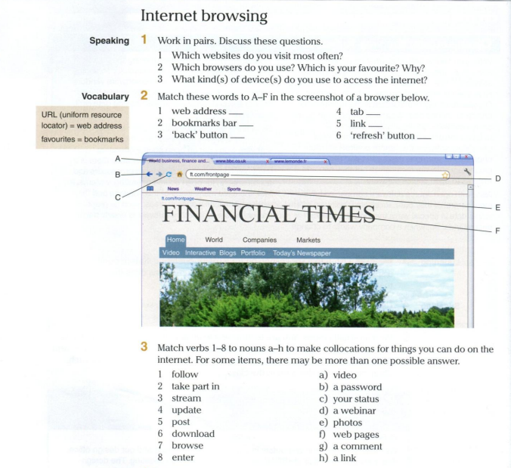

Ex. 1

|  |  |
| --- | --- |
| 1 | I visit most often watching films sites |
| 2 | I always use Safari and Chrome. My favorite is Safari, because the interface is rather user-friendly |
| 3 | I usually use my mobile phone or laptop. |

Ex. 2

|  |  |
| --- | --- |
| 1 | D |
| 2 | E |
| 3 | B |
| 4 | A |
| 5 | F |
| 6 | C |

Ex. 3

|  |  |
| --- | --- |
| 1 | H |
| 2 | D |
| 3 | A |
| 4 | C |
| 5 | G |
| 6 | E |
| 7 | F |
| 8 | B |